Article Title

Ivanov I.I.¹, Petrov P.P.²
¹Institute of Mathematical Problems of Biology RAS, Pushchino, Russia
²Moscow State University M.V. Lomonosov, Moscow, Russia

Abstract. The abstract should be a summary of the work and its main findings. Its text should exclude references and abbreviations, be self-contained, and include only clear notations. The text is limited to one paragraph of 200–250 words, which is about 25 lines, with 1.5 cm right and left margins. URLs may be included only in one case. These must be the links to the websites where data, software or tools referred to in the article are hosted.

Key words: first, second, etc. Organized in a paragraph with full justification and 1 cm right and left margins.

INTRODUCTION
All pages should have the following margins: left – 2.5, right – 2.5, top – 1.7, and bottom– 2 cm.
The Introduction is followed by the text including some examples of text formatting, including references [1−5], equation (1), table (Table 1), figure (Fig. 1) and reference list. We gave the examples of tables and figures design in Table 1 and Figure 1. Abbreviations of word combinations (WC), in capital letters, must be given in parentheses after their first mentioning in the text.
Magnitudes that are followed with measurement units and counts should be written in figures, while the numbers from one to nine not followed by the designations of without measurement units and counts – in words.

TEXT DESIGN
On the arrangement of formulas
We do not consider the manuscripts that use the Office built-in formula editor (Microsoft Editor). It does not provide a functionality that is needed for writing professional mathematical texts. Use the MathType Equation to write formulas properly. One should type long or numbered formulas in a separate line, as for instance,
. (1)
Short mathematical expressions, for example 0.5cos δ·F(y, x), may be typed by the use of math symbols available in the Symbols group in Word. Pay attention to variables (x and y) used in body text, that should be italicized. The symbols should be presented as follows: Greek letters (α, β, γ etc.) – upright font, Roman letters (a, b, c, d etc.) – italics, vectors (r = (i, j, k)) – semibold (without an arrow over a letter), brackets and arithmetic signs – upright. Do not write numbers and short algebraic expressions in MathType Equation. For example, δ(a, h) = 0.34. However, variables with subscripts are better written in MathType: a₀ looks worse than . A number in the normalized form is as follows: 1.66057·10⁻²⁷.
Let us consider the Boyle–Mariotte’s law to illustrate the use of hyphens and dashes. Its mathematical presentation is:
where p is gas pressure; V is gas volume; C is value constant in set conditions.
On the presentation of physical units
Use the International System of Units (SI) for physical units. An examples of presentations are as follows: W/(m·K) or W·m^{–1}·K^{–1}. The measurement units are written through a hard space, for example: 10 °C, 23 K, 123 %.
On the presentation of mathematical statements, theorems, definitions, etc.
Mathematical statements, theorems, their proofs, examples, etc. are presented as a separate paragraph beginning with its name (Definition, Theorem, Proof, Lemma, Example, etc.) separated from the paragraph text with a full-stop. The paragraph is separated both from the preceding and succeeding texts with 6 pt spacings.
Theorem 1. A theorem statement is written in italics, while its heading is accentuated with semibold.
Proof. The word «Proof» is written with the sparse interval. The text of a proof is formatted the same as the main text.
On the presentation of figures
Figure (Fig. 1) should be presented as follows:

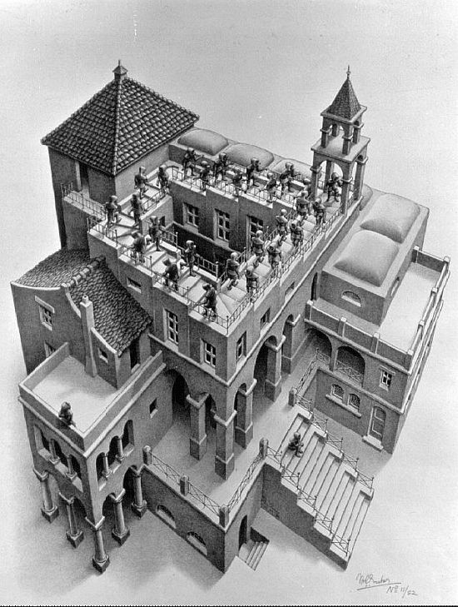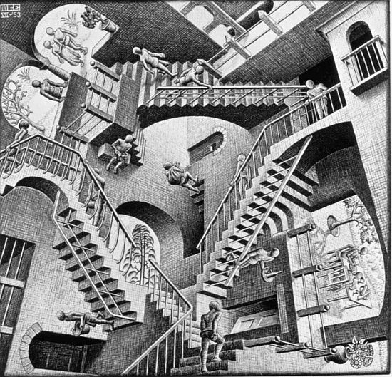
a) b)
Fig. 1. M. Escher’s images: а) Ascending and Descending; b) Relativity. Caption’s left and right idents are 0.5 cm.

The Figure legends should be 10-point font size fully justified like at Figs. 1a and 1b.
On the presentation of tables
Tables (see Table 1) are presented in the same way, while their headings are 11-point font size. A table end is separated from the following text with a blank line. A heading, the same as at Table 1, should be 11-point font size fully justified with 0.5-cm indents from left and right edges of the main text without a full stop at the end. Headings (sub-headings) of columns should be 11-point font size horizontally and vertically centered. A table lines should be 10-point font size.

Table 1. The Earth cosmic velocities
Height over the Earth, km | Velocity, km/s
 | orbital velocity | escape velocity
10000 | 4.93 | 6.98
20000 | 3.89 | 5.50
50000 | 2.66 | 3.76
100000 | 1.94 | 2.74
930000* | 0.65 | 0.93
*A height determines a boundary of the near-Earth-space environment.
Footnotes: 1. Cosmic velocities in the absence of atmosphere.
2. Solar escape velocity is 16.67 km/s.

On the presentation of headings
Headings are typed in semibold upper-case letters and arranged into a paragraph with central justification. The paragraph is separated by 12-pt above and 6-pt below spacings. A heading number, if necessary, is separated with a full-stop. A heading end is not followed with a full-stop.
On the presentation of subheadings
Subheadings are typed in semibold lower-case letters and arranged into a paragraph with left justification. The paragraph is separated by 12 pt above and 6 pt below spacings. A subheading number, if necessary, is separated with a full-stop. A subheading end is not followed with a full-stop.
On the presentation of references and reference list
Where applicable, author(s) name(s), journal title/book title, chapter title/article title, year of publication, volume number/book chapter and the article number or pagination must be present. Use of DOI is highly encouraged.
The following section (REFERENCES) gives some examples of correct citing. In the text, the reference goes in square brackets. References should be numbered in the order of their appearance in the article. The first two references [1, 2] are an example of references to journal publications. The second item [2] exemplify the reference to a journal publication with article number, the third [3] – to a chapter in a book, the next three [4–6] to entire books. The item [7] is an example of reference to a web-site., [8] – reference to a dataset, the last item of the list [9] – reference to a software.
Please, pay your attention to the arrangement of spaces and signs of punctuation. No commas between author’s name and initials (example: John J.J.). Page range (P. 121–123) should be written using short dash (–) typed as (Ctrl Num -).
A reference to an article of up to 10 authors includes the names of all of them, otherwize the first ten names is followed by “et al.”. A reference to electronic resource (web site) should contain the main bibliographic information followed by its URL and date the document was accessed. In the case of an electronic publication (a journal article), the reference should be followed with DOI.
A reference list must contain 20 or more references, and not more than 25 % of them can be self-references. Do not refer dictionaries and encyclopedia!
REFERENCES
- Khlebodarova T.M., Likhoshvai V.A. New evidence of an old problem: the coupling of genome replication to cell growth in bacteria. Russ. J. Genet. 2014. V. 50. No. 9. P. 891–901. doi: 10.1134/S102279541408002X.
- Liu W.-Y., Wong C.-F., Chung K.-M., Jiang J.-W., Leung F.C.-C. Comparative genome analysis of Enterobacter cloacae. PLoS One. 2013. Article No. e74487. doi: 10.1371/journal.pone.0074487
- Petrov P.P., Sidorov S.S. In: Interacting Particle Systems. Eds. Ivanov I.I., Petrov P.P. Chichester: John Wiley and Sons, 2004. P. 11–23.
- Petrov P.P. Quantum Mechanics. New York: Springer-Verlag, 1977. 567 p.
- Lewin B. Genes. John Wiley and Sons, 1983. 566 p.
- Ivanov P.P. Methods of Applied Mathematics. Moscow: Science, 2010. 355 p.
- Tandem repeat finder. URL: http://tandem.bu.edu/trf/trf.html (accessed 02.03.2015).
- Oguro M., Imahiro S., Saito S., Nakashizuka T. Mortality data for Japanese oak wilt disease and surrounding forest compositions. Mendeley Data, 2015. doi: 10.17632/ xwj98nb39r.1
- Coon E., Berndt M., Jan A., Svyatsky D., Atchley A., Kikinzon E., Harp D., Manzini G., Shelef E., Lipnikov K. et al. Advanced Terrestrial Simulator (ATS) (Version 0.88). Zenodo, 2020. doi: 10.5281/zenodo.3727209.

